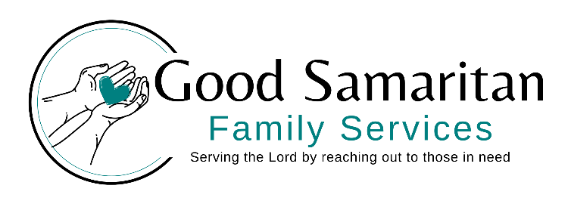
TEE UP FOR FAMILIES SPONSORHIP FORM

Business Name: _____________________________________________________
Address: ___________________________________________________________
Contact Name: ______________________________________________________
Phone Number: _____________________________________________________
Email: _____________________________________________________________

Sponsorship Level:
______ Gold Hole Sponsor - $750 (large sign on tee and in program)
_______ Silver Hole Sponsor - $500 (medium sign on tee and in program)
_______ Bronze Hole Sponsor - $250 (small sign on tee and in program)
_______ Event Sponsorships – $1000 (signs on tees and also on banner and on all materials)
_______ In-kind donations such as raffle items or door prizes are also greatly appreciated.- when and where I should pick up
______________________________________________________________________________

Please include logo or email to robyn@thegoodsam.org
Call Robyn Yarmak at 231-588-2208 (O) or 517-285-0759 (C) with any questions
You can mail checks to PO Box 206, Ellsworth, MI 4972
Please send back by June 30, 2026.

