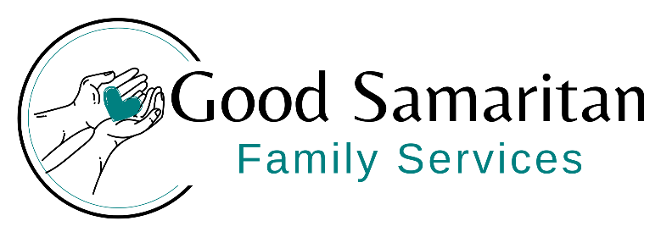
_________________________________________________________________________________________________
Dear Community Partner,
Our team at Good Samaritan Family Services is excited to announce our upcoming Tee-Up for Families Golf Fundraiser, taking place on August 23 at Antrim Dells Golf Course. This event is one of our most important annual fundraisers, helping us provide nutritious food and essential support for families throughout our community.
As the need for food assistance continues to grow, we rely on the generosity of local businesses to keep our shelves stocked and our programs running. Your support directly impacts neighbors who are facing food insecurity, many of whom are working families, seniors, and children. Half our proceeds are going to our Moms & Tots program where we help mothers and their young children with a variety of needs.
We would be honored to have you join us as a sponsor. Several sponsorship levels are available, each offering valuable visibility and recognition:
- Gold Hole Sponsor - $750 (large sign on tee and in program)
- Silver Hole Sponsor - $500 (medium sign on tee and in program)
- Bronze Hole Sponsor - $250 (small sign on tee and in program)
- Event Sponsorships – $1000 (signs on tees and also on banner and on all materials)
- In-kind donations such as raffle items or door prizes are also greatly appreciated.
Your partnership not only supports a meaningful cause but also demonstrates your commitment to strengthening our community. We would love to showcase your business to our golfers, volunteers, and supporters throughout the event.
If you are interested in sponsoring or would like more information, please contact Robyn Yarmak at robyn@thegoodsam.org. Sponsorship commitments received by June 30th will be included in all event materials. Sponsorship form included to mail back with payment.
Thank you for considering this opportunity to make a lasting difference. We truly appreciate your support and hope to see you on the course!
Warm regards,
Robyn Yarmak
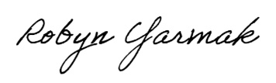
Executive Director, GSFS
Serving the Lord by reaching out to those in need
_________________________________________________________________________________________________
P.O. Box 206 Ellsworth, MI 49729
231.588.2208
Good Samaritan Family Services IRS Federal ID#38-3469219
No goods or services were provided in exchange for this donation
WWW.THEGOODSAM.ORG

